

A Project Report

On

Parents Record Book

By

Ashwini Patil

B.Tech

Batch: - 2020 – 4965

Center:- Pune Chinchwad

Under the Guidance of,

Jayant V.

Technical Trainer

EduBridge

(School of coding)

Introduction:

Our project explains about the parents record book . This project mainly explains the various actions related to parents and when parents come in school then first to register in book and again register but in this project parents only one time register than parents come again than only login.that why I Create project. This Project is designed to keep the records of Parents entering the gate and their information.

.

Our Project Includes:-

∙ Parents Information

I have developed this Application in Java, JSP, Servlets and MySQL. It’s a web based project so I have used HTML.

The main feature of the project is to manage the records of parents In Faculty module.

Software Requirements:

Front end: Java/J2EE technologies (Servlet, JSP), HTML, CSS, JDBC.

Back end: MySQL.

Middleware/Server: Apache Tomcat v9.0.

IDE: Eclipse IDE for Java EE Developers Browser: Best result on Google Chrome

Operating System: Window 10.

Data Dictionary:

Table name: user7

CREATE TABLE stu_details (

userid int not null,

pass varchar(30) not null,

first varchar(50) not null,

Surname varchar(50) not null,

Email varchar(50) nut null,

contactno varchar(50) not null,

Address varchar(50),

city varchar(50) nut null,

aadharno varchar(50) nut null

PRIMARY KEY (userid)

)

Screenshots :-

Home Page:-

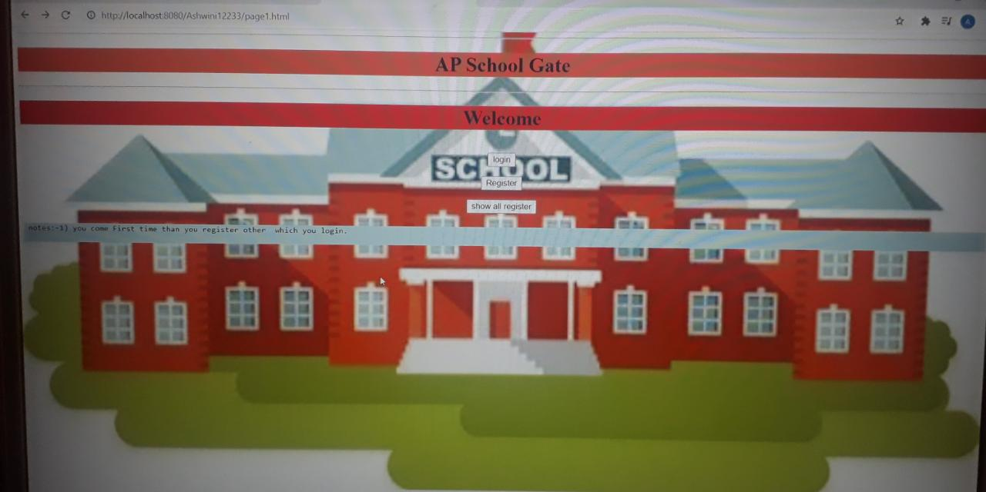

Login Page :-

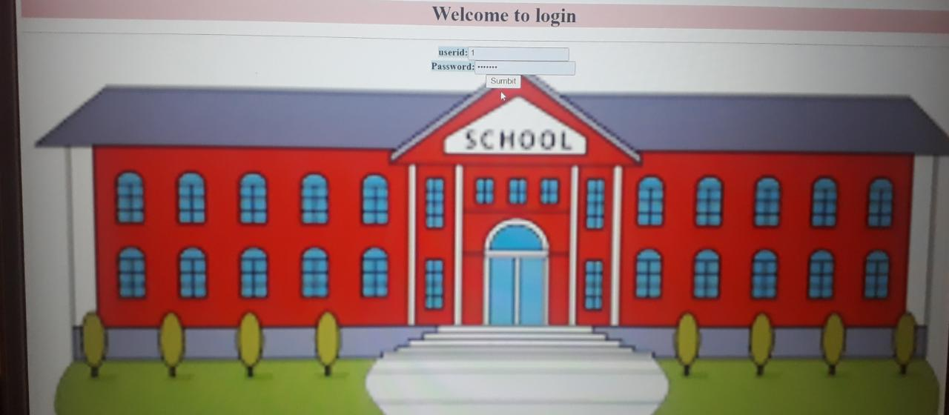

Login not Sucessfully :

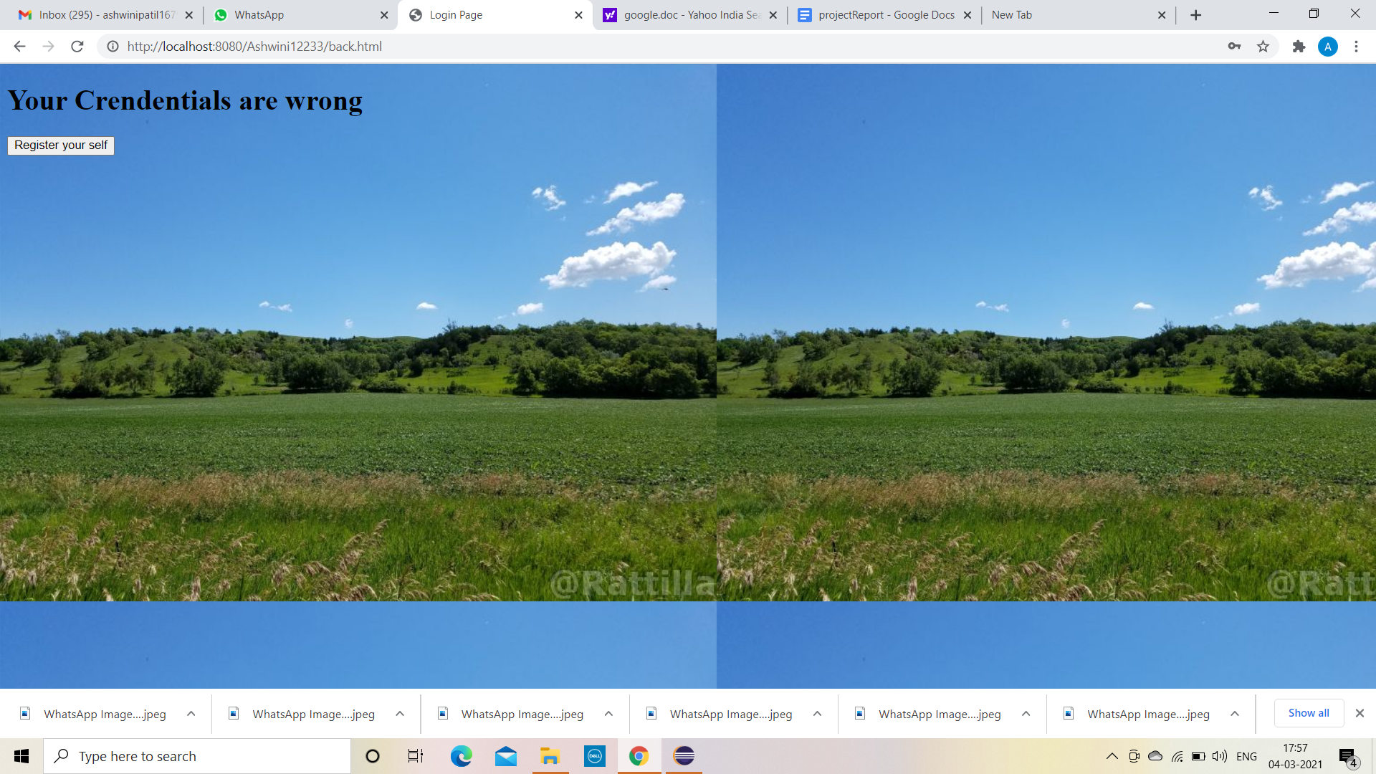

Registration Information :-

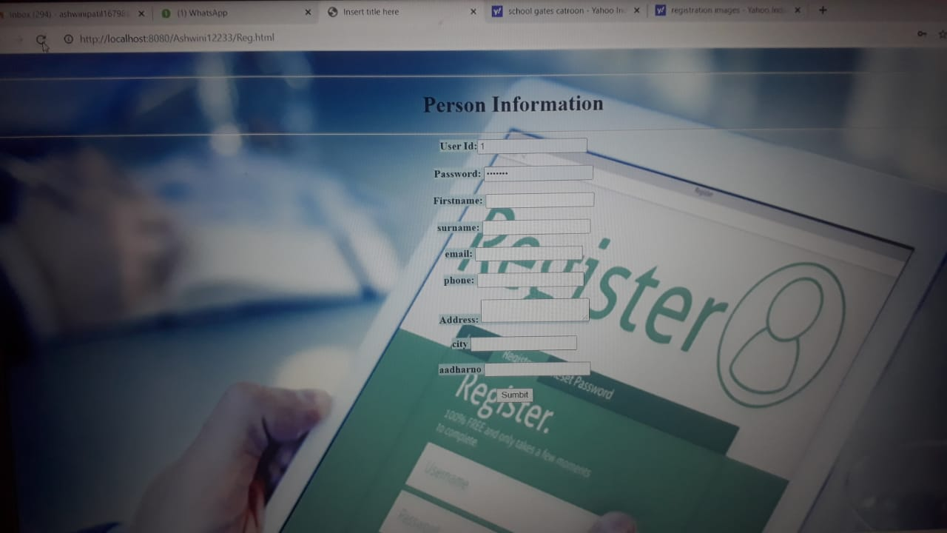

Show Details Page:-

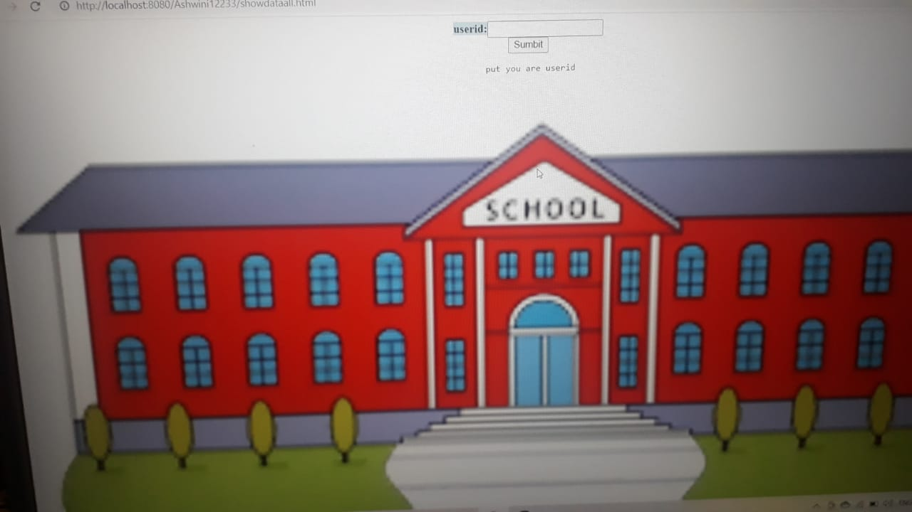

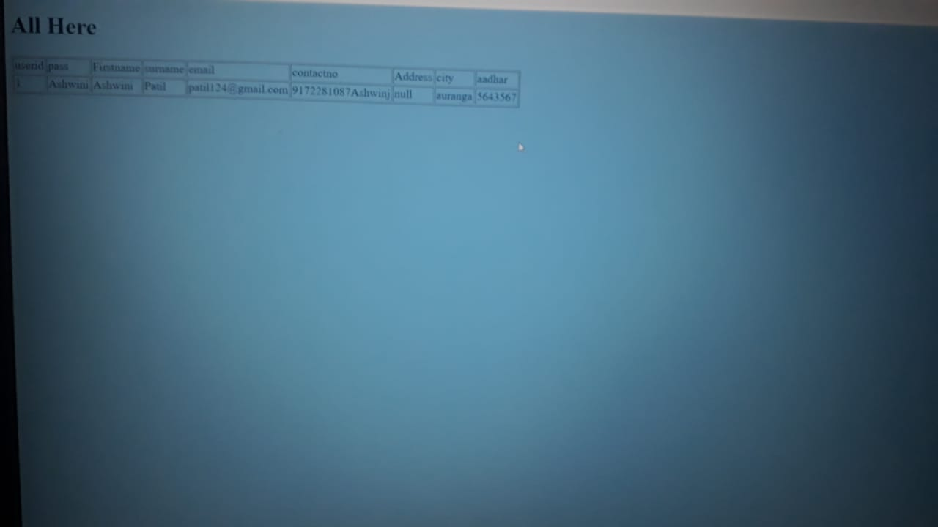

Logout page :-

